
AMERICAN INTERNATIONAL UNIVERSITY-BANGLADESH
Faculty of Science and Technology
Department of Computer Science
CSC 3215: Web Technologies

Semester: Summer 2025-26 | Group No: 2 |  | Section: | U

Group Members:
SL. | Student ID | Name | Role | Signature
1 | 23-53342-3 | Md. Ashiq Bin Hamid | Group Leader
2 | 23-53372-3 | MD. KHAIRUL ALAM | Member
3 | 23-53672-3 | Zerin Hoque | Member
4 | 23-54091-3 | Mashfia Huda Mim | Member
Project Title
CRAVERUSH – Food Delivery Management System
Short Description
CRAVERUSH is a web-based food delivery management system connecting Customers, Restaurants, Deliverymen, and Admins. Customers can browse food, place orders, make payments, track deliveries, cancel pending orders, and review restaurants. Restaurants manage food items and orders, Deliverymen handle assigned deliveries, and Admins manage users, orders, deliveries, revenue, and restaurant requests.
Introduction
Food delivery services have become an important part of modern online commerce. Customers expect to be able to discover restaurants, select food, place orders, make payments, and receive their orders conveniently through an online platform. At the same time, restaurants require an organized system for managing menus and incoming orders, while delivery personnel need an efficient way to receive and complete delivery assignments.
CRAVERUSH is proposed as a multi-user web-based food delivery management system that brings these activities together on one platform. The system contains four main types of users: Admin, Customer, Restaurant, and Deliveryman. Each user has different responsibilities and has access to different functionalities.
Customers can browse restaurants and food items based on their assigned area, manage their cart, place orders, make payments, track deliveries, request cancellation of pending orders, and review restaurants after successful delivery.
Restaurants can manage their menus and food items, modify prices and availability, and process customer orders. When an order becomes ready, the system identifies an eligible deliveryman in the same area.
Deliverymen are responsible for receiving assigned orders, picking them up, updating delivery status, and completing deliveries. They can only receive assignments when they are Online and Available, and a deliveryman can handle only one active order at a time.
The administrator provides overall system management. The admin can manage users, monitor orders and deliveries, handle restaurant area-change requests, monitor CRAVERUSH revenue and profit, deactivate restaurants, and configure the fixed delivery fee.
CRAVERUSH also incorporates payment, cancellation, review, area-management, revenue-management, and historical-data requirements. Online payment is simulated, while Cash on Delivery remains pending until the order is delivered and the payment is collected by the deliveryman.
Background Study
Traditional food ordering can be time-consuming and difficult to manage manually. A centralized web-based system can make ordering, payment, restaurant management, and delivery tracking more efficient. CRAVERUSH addresses these requirements through role-based functionality and an organized order workflow:
Pending → Preparing → Ready → On the Way → Delivered
ER Diagram
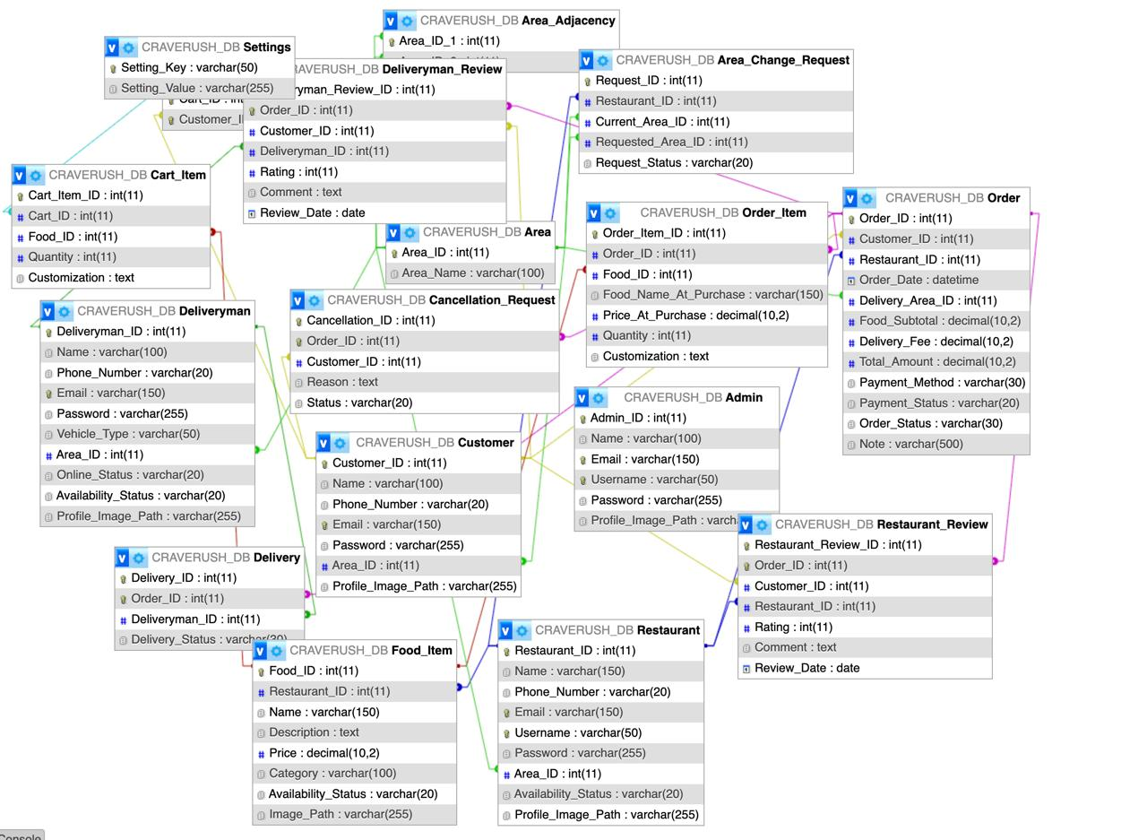

Use Case Diagram
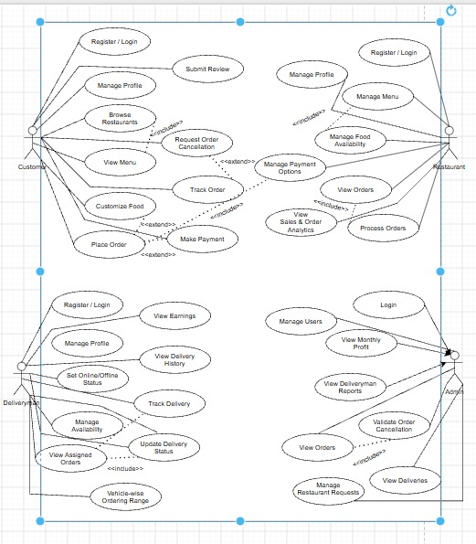.

UI (Figma/Sketch)
Login and Account Creation:
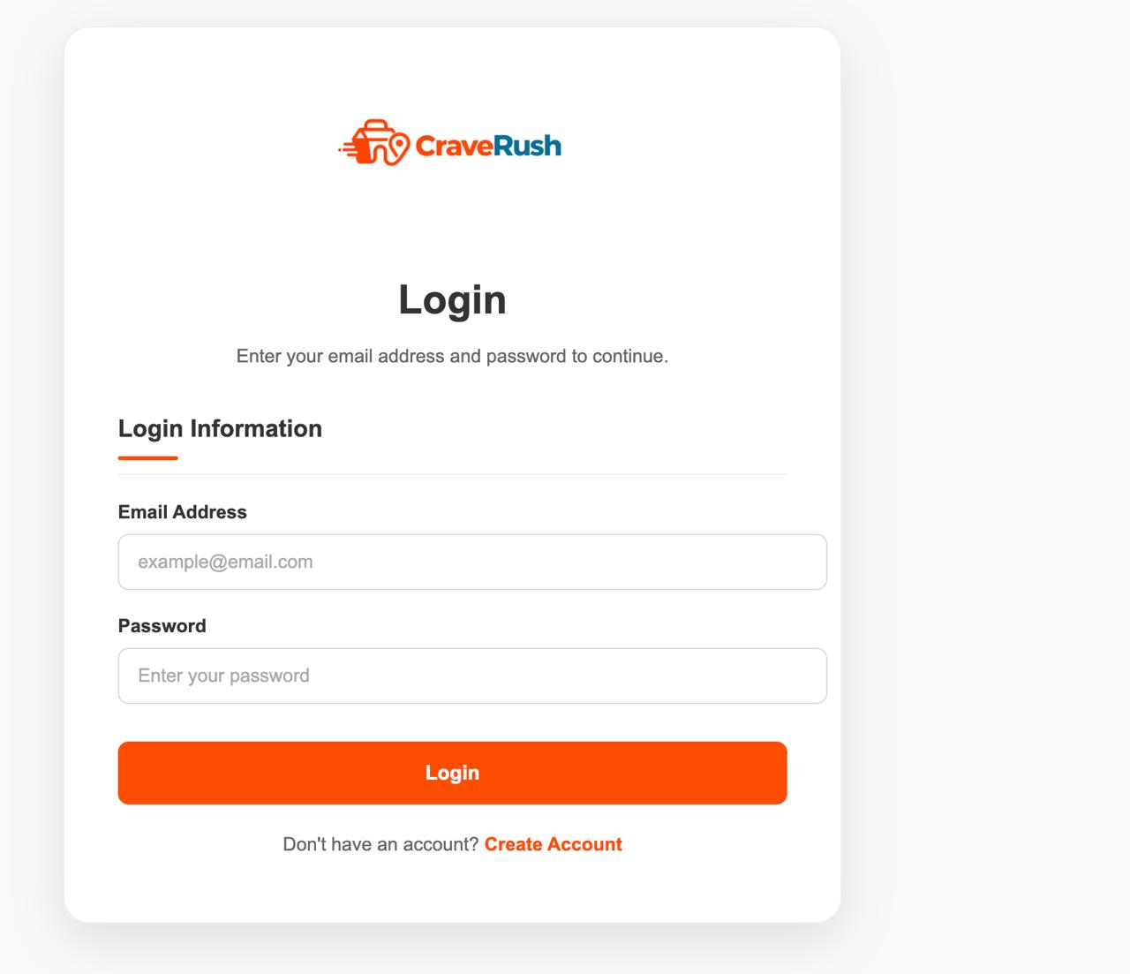
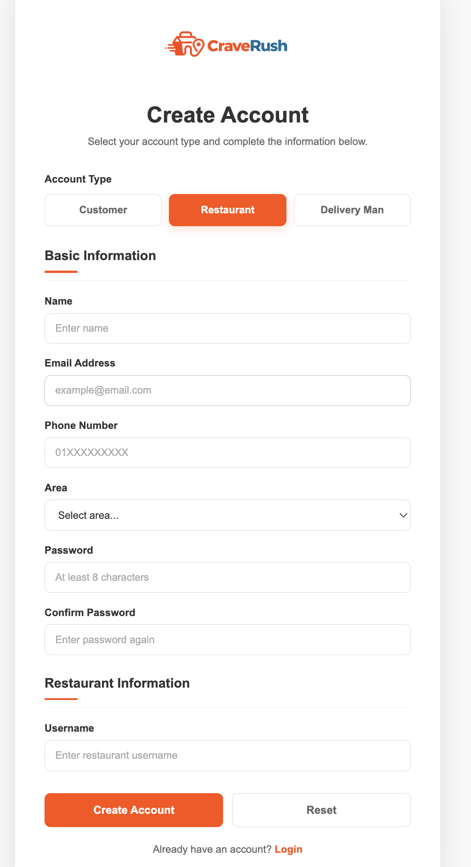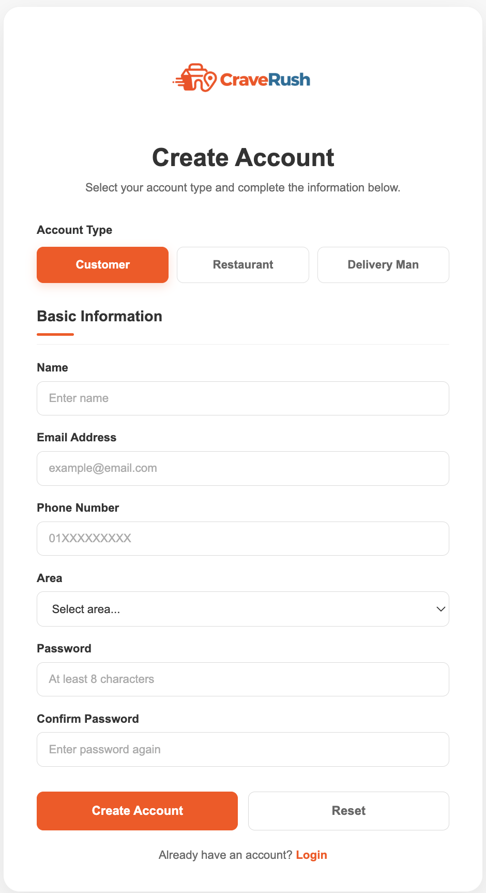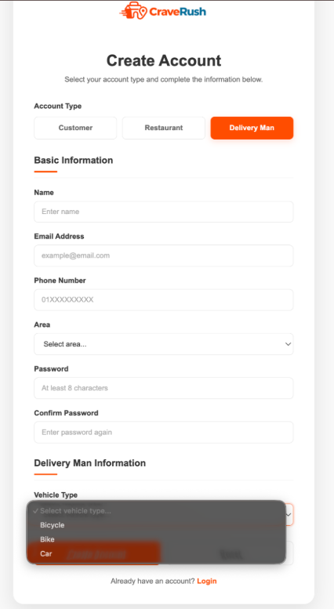

Unique Features ( Admin ):
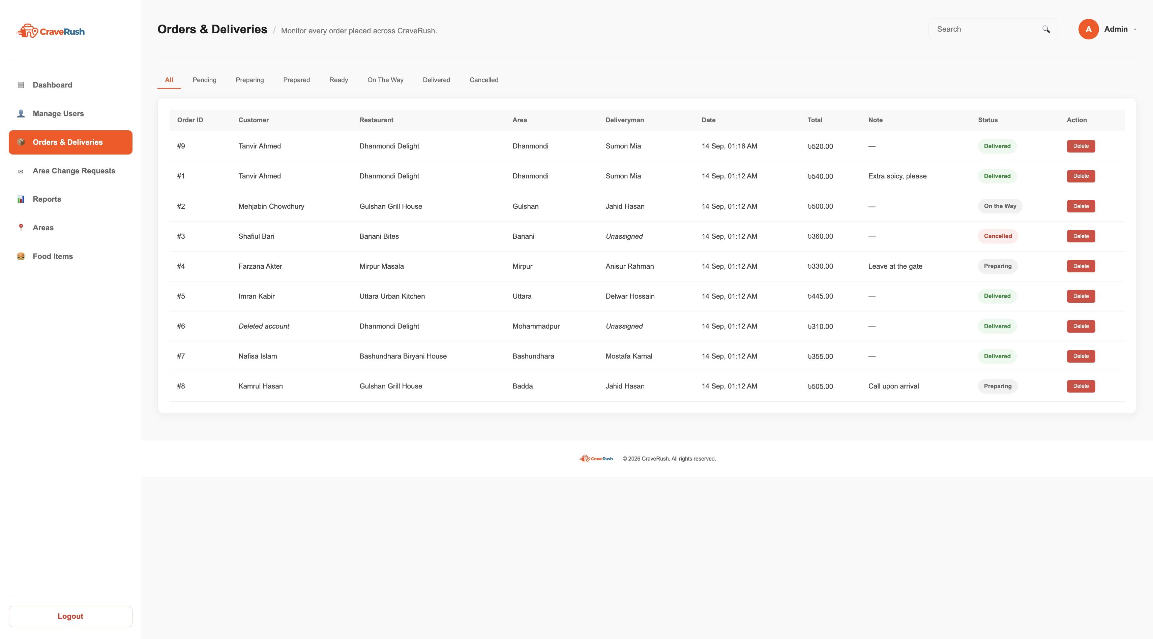
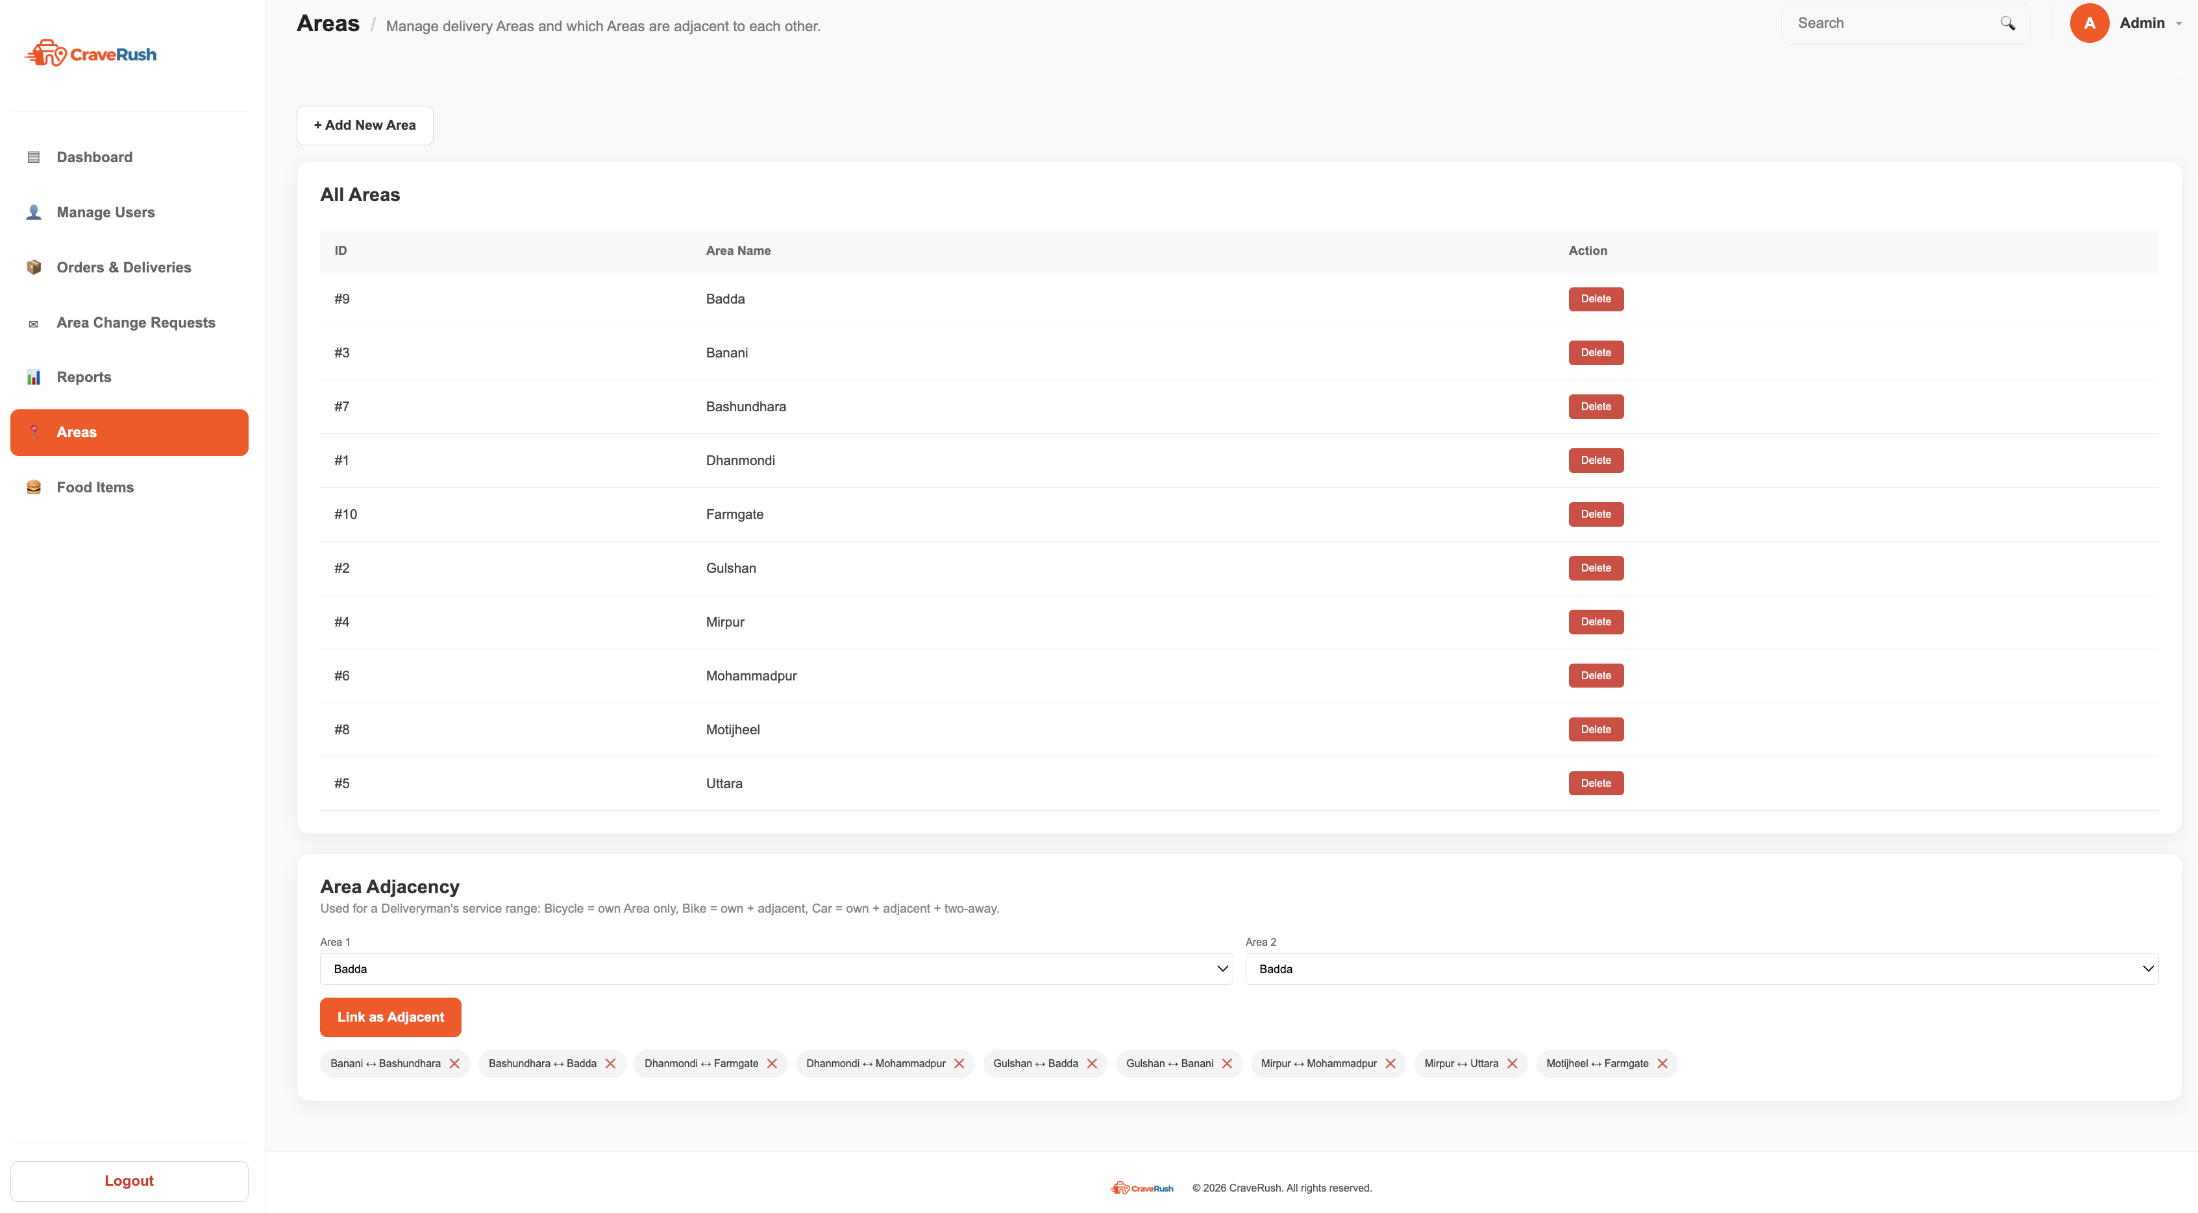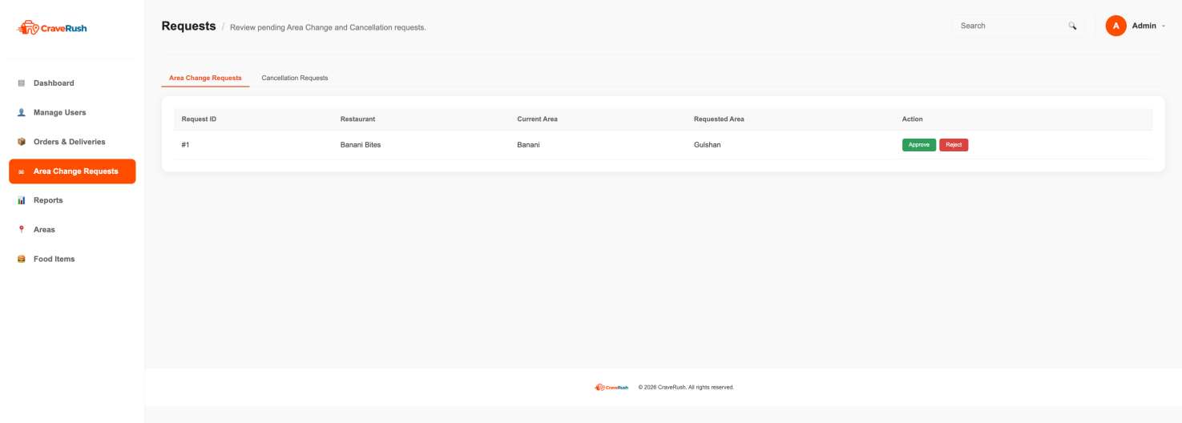

Unique Features ( Customer ):

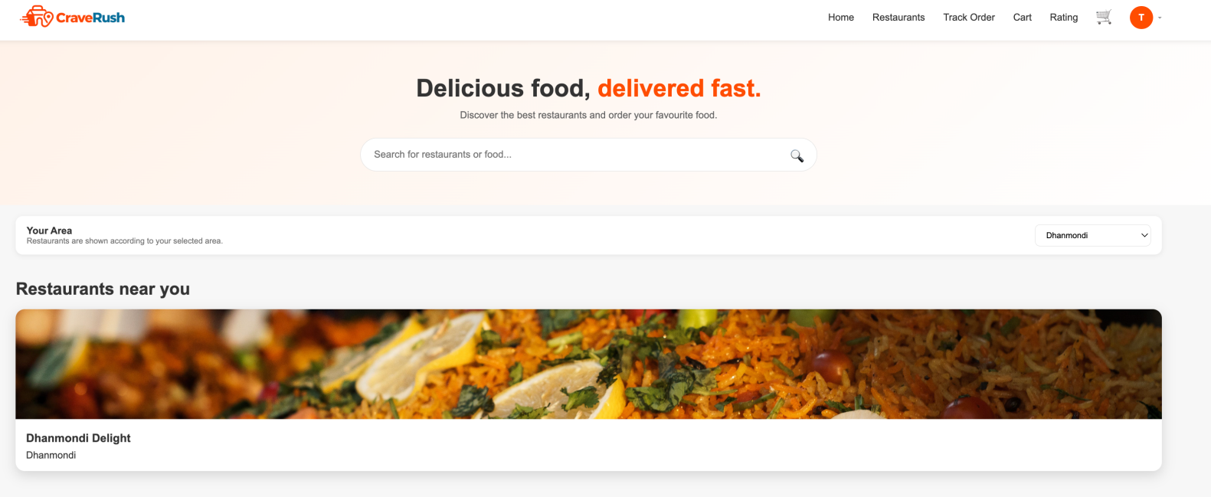

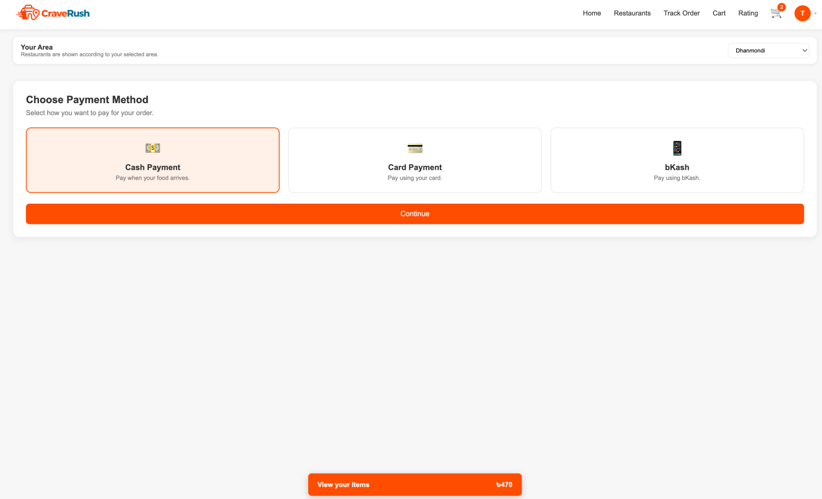

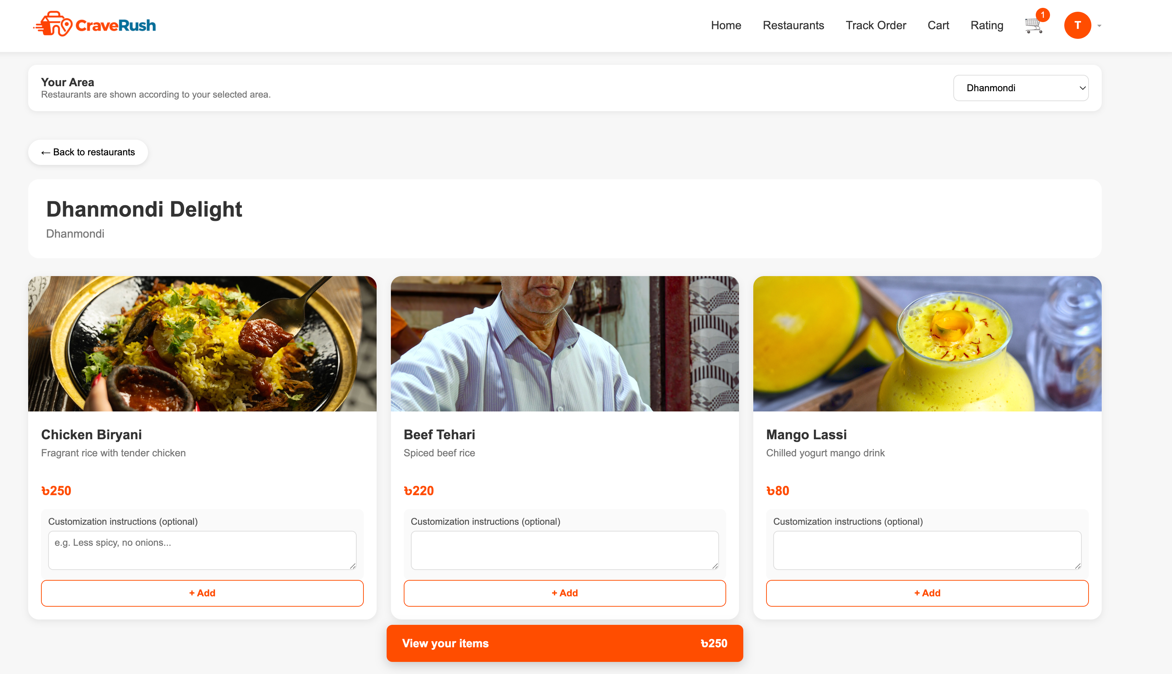

Unique Features ( Restaurant ):

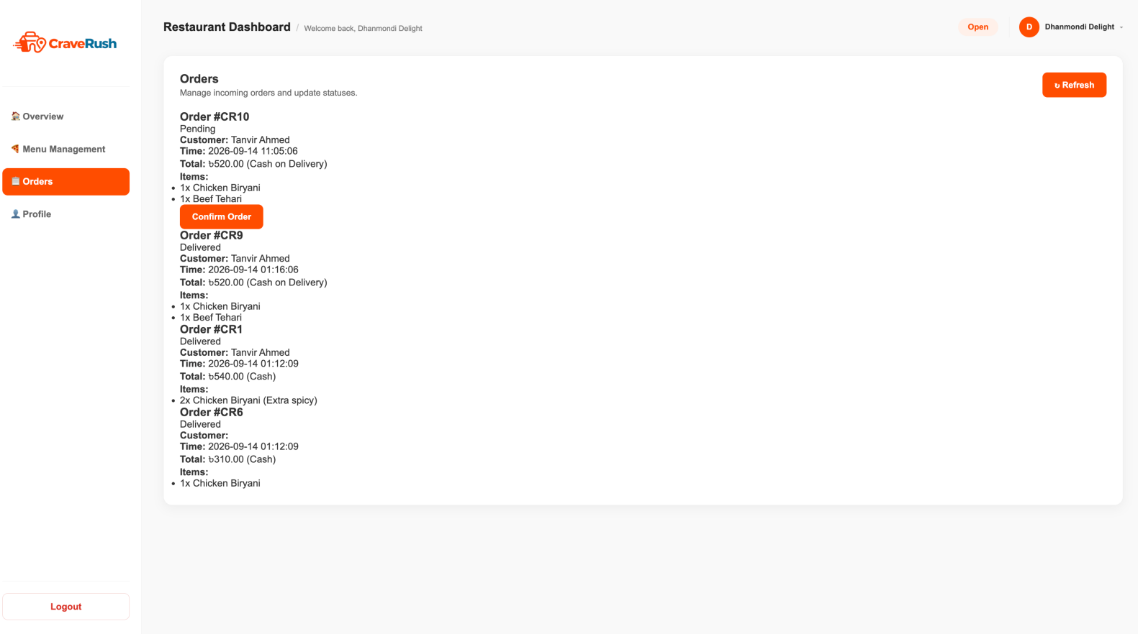

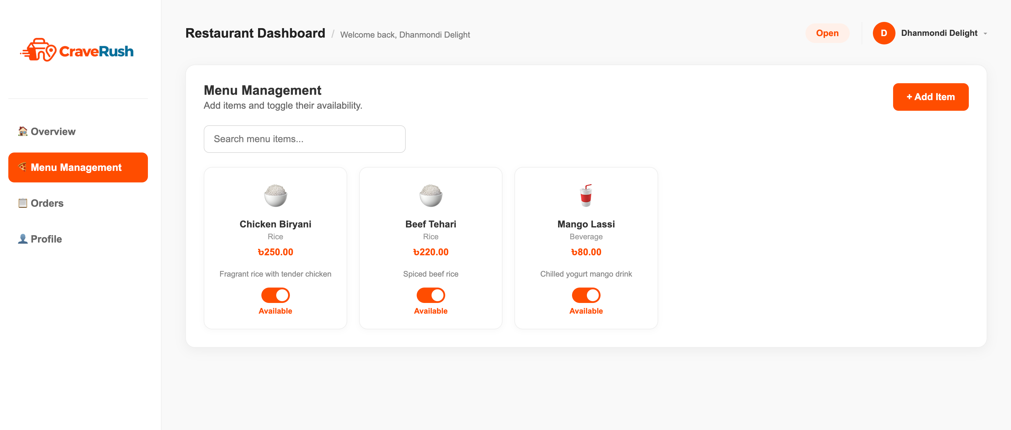

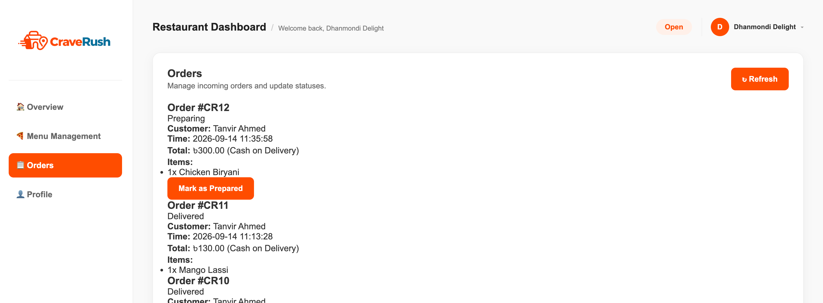

Unique Features ( Deliveryman ):

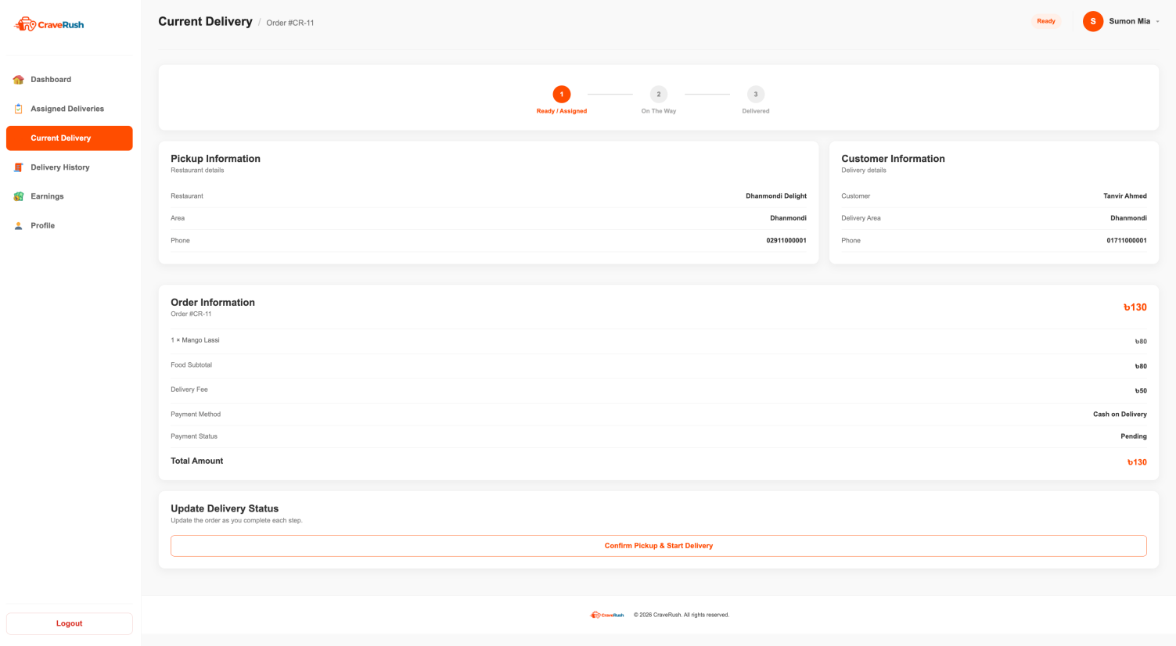
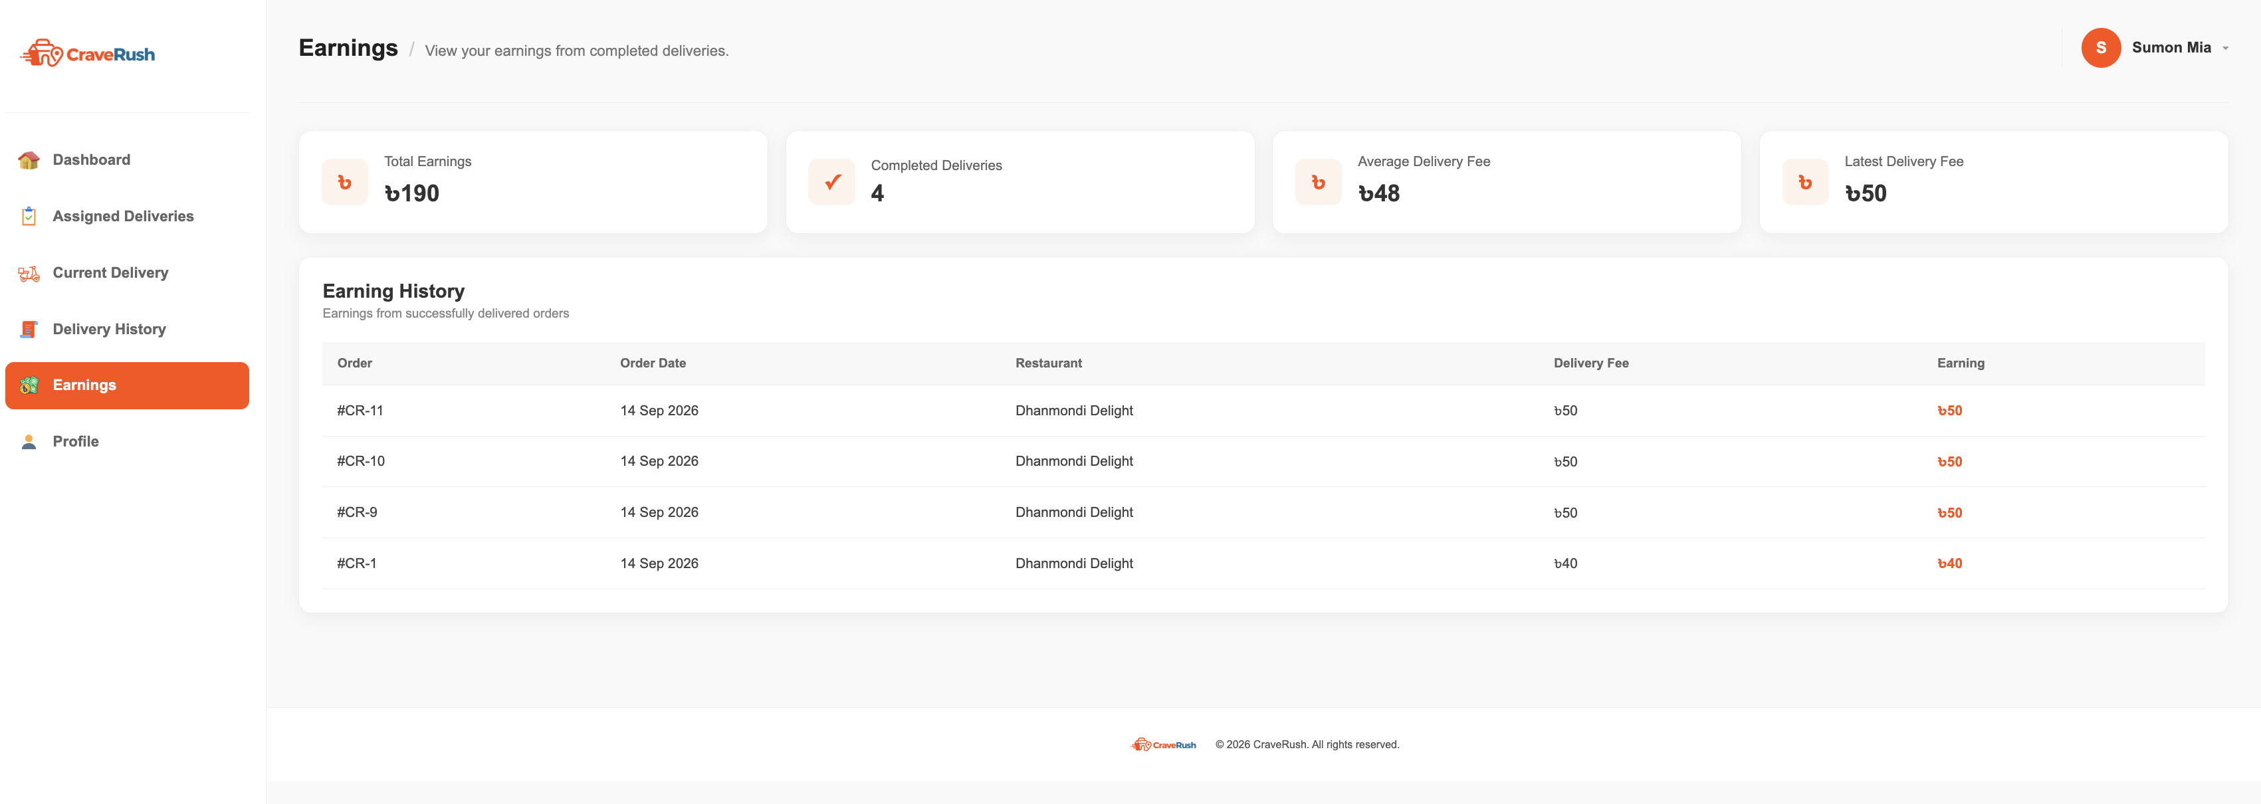
Types of Users: 1. Admin 2. Restaurant 3. Customer 4. Deliveryman
Common Features (Available to All Users)
- Authentication
- Login to the system
- Logout from the system
- User registration
- Account Management
- Change or reset password
- Manage profile information (view, edit, delete)
- Dashboard
- Access a personalized dashboard after login
Specific Features by User Type
- Admin
- Monthly Profit Monitoring
- Deliveryman Reports
- Order Cancellation Validation
- Restaurant
- Menu and Availability Management
- Sales and Order Analytics
- Payment Options
- Customer
- Food Ordering, Customization and Payment
- Order Tracking
- Review
- Deliveryman
- Vehicle-wise Ordering Range
- Delivery Status and Tracking
- Delivery History and Earnings

N.B: Each user type must have at least 3 distinct features different from the others. Additional features may be added if desired. Proposals with generic, incomplete, or duplicated features across user types will receive reduced marks under the criteria below.

